Macro exam
Part 1
I’ve written a small note underneath when I believe the answers might be a little ambiguous

1)
C

B and C are strongly correlated thus this is the one we usually track

2)
d

3)
A,b,c,d

4)
B,c,

D is a little tricky, it can be interpreted as as simply a decrease of money demand which doesn’t shift the MD curve which ill do
For the sake of an answer ill say its not true

5)
A is true

All other answers depend on the timeframe in question and become ambigous

6)
D

7)
A

8)
B
D

9) assuming that population growth isent negative
A

10)
B

11)
D

Part 2
Explain!

12)
A person smoothing his or her consumption would want a flat line of consumption and thus close to a 0 change of consumption if possible
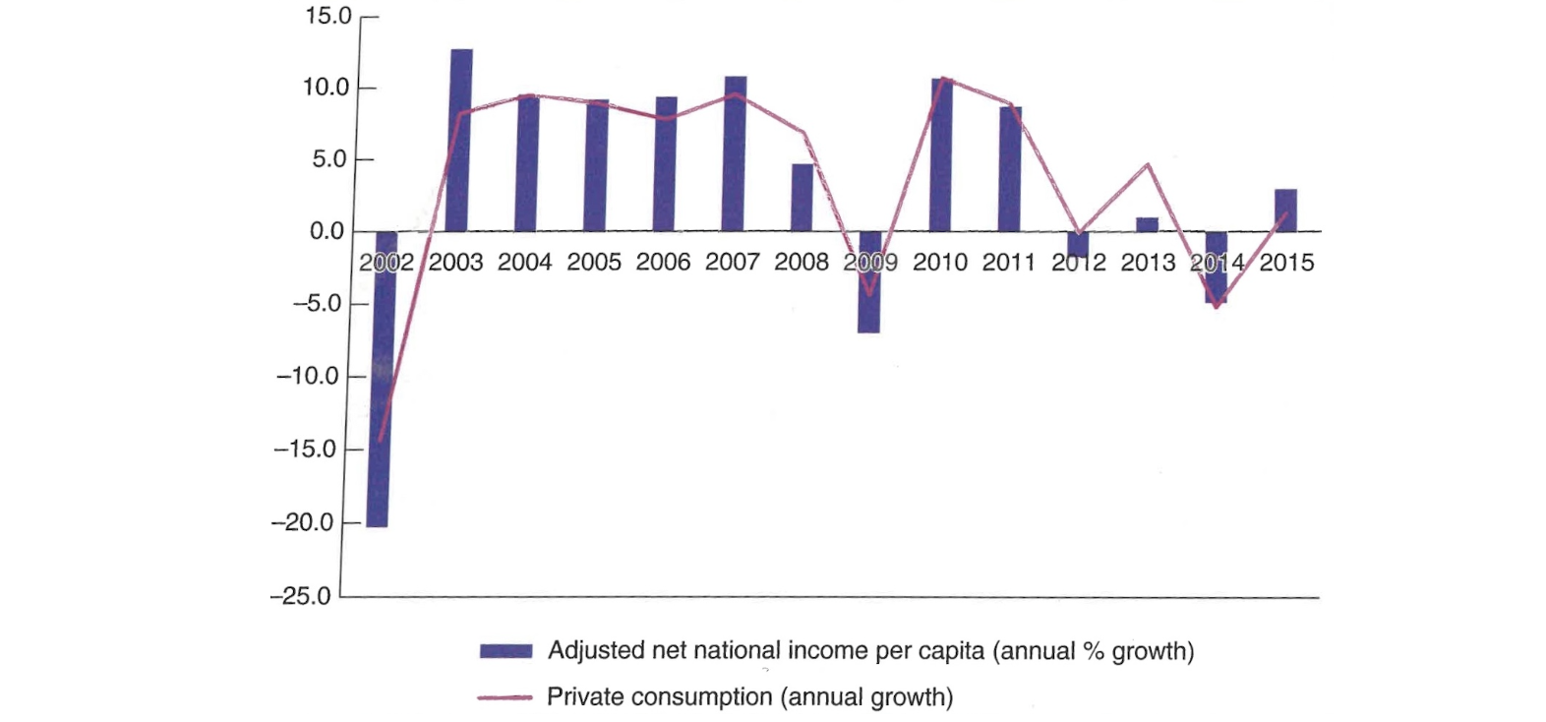
Looking at the graph we see that whenever output moves so does consumption indicating that people aren’t taking out loans to increase their standard of living and not saving in periods with high income
There are a couple of periods namely in 2002,2003 and 2009 that might indicate some kind of smoothening.

for me to conclude that they are smoothening their income I would need a flatter line of consumption

Thinking back I remember something about the Argentinian economy having quite high inflation which would complicate the answer quite a lot but I will not take that into account
I would conclude FALSE

13)
The idea of the carry trade that UIP doesn’t quite hold all the time
$$1+i=\frac{\left(1+i^{⋆}\right)E_{t}}{E_{t+1}^{e}}$$
Or its approximation:
$$i≈i^{⋆}-\frac{ΔE}{E}$$

The idea is that you are able to make a profit by investing in the high interest rate currency instead of your own and make a profit

When UIP holds and by the assumptions of the assignment
Since $i^{⋆}<i$ UIP states that
$$ΔE<0$$
Which means we expect a depreciation,
In the data we see the exact opposite from feb til aug
This is the carry trade where traders are able to make a profit by investing in yen

Then in early September and October we see a sharp depreciation which has been described as the unwinding of the carry trade, one could argue that this is an example of a rational speculative bubble where the unwinding is simply the price of yen going back to fundamentals
Yes this is consistent with the idea of the unwind of the carry trade
TRUE

14)
A hard peg doesn’t magically solve your problems with high inflation it can help though if you have high market integration or similar economic shocks
since an increase in prices in your home country would decrease domestic output since
$$ϵ=E·\frac{P}{P^{˜⋆} }$$
When prices go up relative to your pegged counterpart
$$\frac{P}{P^{⋆}}↑⇒ϵ↑⇒NX↓$$
then output decreases and inflation decreases, also a peg to a country with a history of good monetary policy could make your citizens have an easier time reanchoring their expectations(if we were already having accelerating inflation)
this is all on the const of loosing monetary policy autonomy(which could be really bad if your pegged counterparty doesn’t have similar shocks)
thus I would conclude that yes anchoring your currency can be a way of combatting high inflation
TRUE

15)
a)
nominal GDP
2015:
$$10·20+5·10+10·5=300$$
2016:
$$12·30+6·12+12·4=480$$
Change:
$$\frac{\$Y_{t+1}-{\$Y}_{t}}{\$Y_{t}}=\frac{180}{300}=0.6=60\%$$
b)
2015 already there
$$=300$$
2016:
$$12·20+6·10+12·5=12·30=360$$
Now change in real GDP( in 2015 dollars)
$$\frac{Y_{t+1}-Y_{t}}{Y_{t}}=\frac{60}{300}=0.2=20\%$$
c)
since 2015 is the basisyear
$$P_{2015}=1$$
2016
$$P_{2016}=\frac{\$Y_{2016}}{Y_{2016}}=\frac{480}{360}=\frac{4}{3}$$
$$π_{2016}=\frac{P_{2016}-P_{2015}}{P_{2015}}=\frac{1}{3}=33.3\%$$

d)
another common measure is the consumer price index which tracks the pricelevel of a basket of consumer goods, this measure tracks the pricelevels influence on the consumer

16)
in EQ we must have $Z=Y$
$$Z=C\left(Y-T\right)+I\left(Y,i\right)+G$$
From equations given
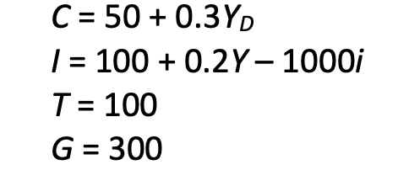
$$Y=50+0.3·\left(Y-100\right)+\left(100+0.2Y-1000i\right)+300$$
We solve for Y to make a function of i
$$Y\left(1-0.3-0.2\right)=50-30+100-1000i+300$$
$$Y=\frac{1}{0.5}·\left(20+100+300-1000i\right)=\frac{1}{0.5}·\left(420-1000i\right)$$
Or I as a function of Y so we can draw it easily
$$1000i=420-2Y⇒\frac{420-2Y}{1000}$$

We find Y
$$Y=\frac{1}{0.5}·\left(420-1000i\right)=2·\left(420-20\right)=800$$
C
$$50+0.3·\left(800-100\right)=50+210=260$$
I
$$100+0.2·800-20=100+160-20=240$$
We simply check that this is equal to output
$$260+240+300=800$$
b) a decrease in tax leads to an increase in consumption which then has the usual multiplier effect on a graph this would mean the is curve shifts to the right
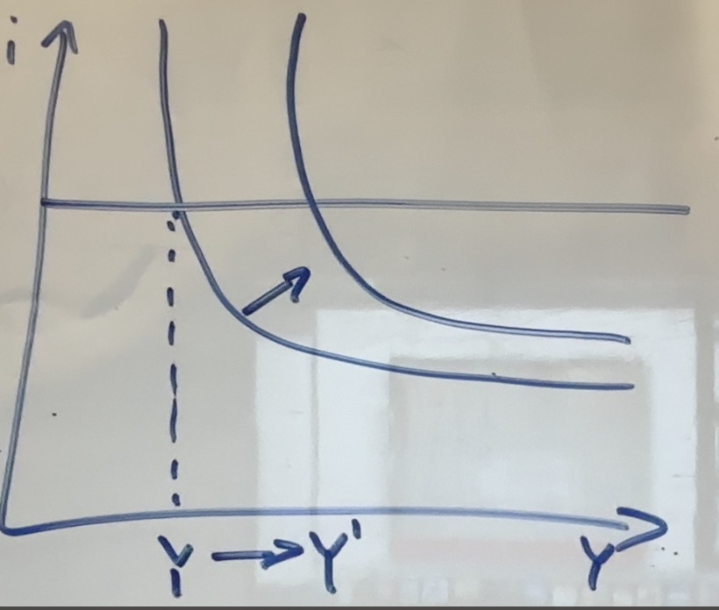
We know that a Decrease in T leads to an increase in C which means an increase in Y which increases both C and I this goes around until we hit a new EQ
We see that this change would increase C more than it does I (in relative terms since I is often much smaller than I) since consumption is the primary change that happens after a decrease in tax

c)
no trumps statement would be a decrease in tax and thus an increase in budget deficit
$$budget deficit=T-G$$
$$T↓⇒budget deficit↑$$
One argument could be that he believes we are already above the natural rate of output meaning that they would want to decrease output rather than increase it(since an increase in budget deficit increases output) thus on the IS-LM-PC curve they would rather:
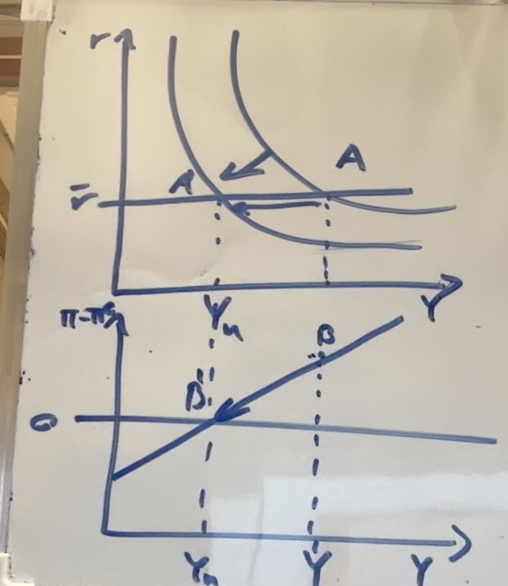
Decrease the budget deficit to reduce output move us from A to A’
and put inflation closer to expected inflation move us from B to B’
Said quicker :
Gita might think that the economy is already overheating and that to decrease excess inflation we should, instead of increasing output reduce it

d)
to decrease output back to natural levels we would need to increase the interestrate thus a monetary contraction this would lead to a decrease in investment which decreases output which decreases both C and I which decrease output this continues untill we hit EQ
in the is-lm model we can draw it
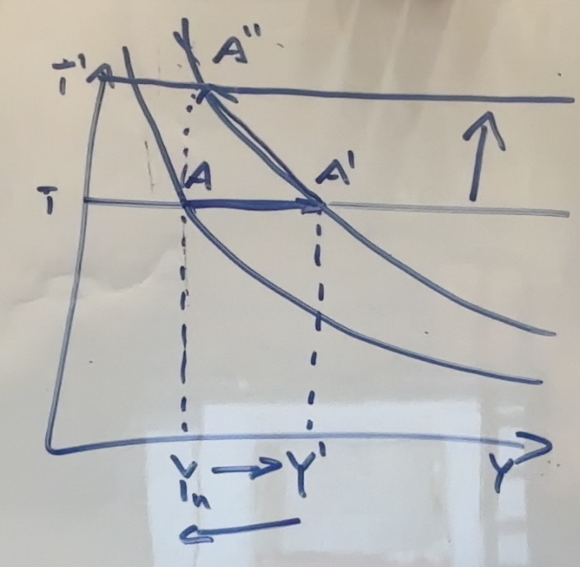
The decrease in tax takes us from $Y_{n}$ to Y’
To get back to the natural rate of output we increase interest rates from $\overline{i}$ to $\overline{i}'$
Shifting the LM curve and taking us back to the natural rate of output

To have a deflation spiral we would need to have a negative output gap and be lose to the Zero lower bound such that we cannot get back to the natural output rate
In this situation since we are not in a deflation spiral before the change(I assume) we could only get into a negative output gap by reacting to harshly to the change in tax but in that case we could simply shift back interest rates to get closer to our wanted output level
No there is no concern for a deflation spiral
e)
to increase interest rates the central bank would need to decrease the money supply by selling bonds shown on the balance sheet
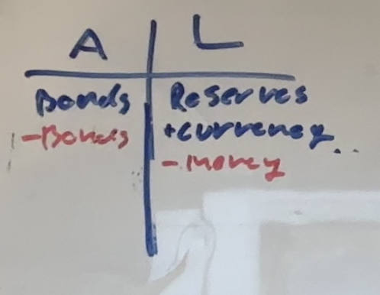

17)
a) yes it does since
$$f\left(x·K,x·AN\right)={\left(x·K\right)}^{\frac{1}{2}}·{\left(x·A·N\right)}^{\frac{1}{2}}=x·K^{\frac{1}{2}}·AN^{\frac{1}{2}}$$
b) first we make it a function one variable
$$\frac{Y}{AN}=f\left(\frac{K}{AN}\right)={\left(\frac{K}{AN}\right)}^{\frac{1}{2}}$$
Steady state condition states
$$s·\frac{Y}{AN}=\frac{K}{AN}·\left(δ+g_{A}+g_{N}\right)$$
$$0.2·{\left(\frac{K}{AN}\right)}^{\frac{1}{2}}=0.1·\frac{K}{AN}$$
$${\left(\frac{K}{AN}\right)}^{\frac{1}{2}}=2$$
Kapital/effective worker
$$\frac{K}{AN}=4$$
Output/effective worker
$${\frac{Y}{AN}=\left(\frac{K}{AN}\right)}^{\frac{1}{2}}=\sqrt{4}=2$$
Growth of output per effective worker (these are known since we are in steadystate)
$$g_{\frac{Y}{AN}}=0$$
$$g_{\frac{Y}{n}}=g_{A}=4\%$$
$$g_{Y}=g_{A}+g_{N}=4+2=6\%$$
c)
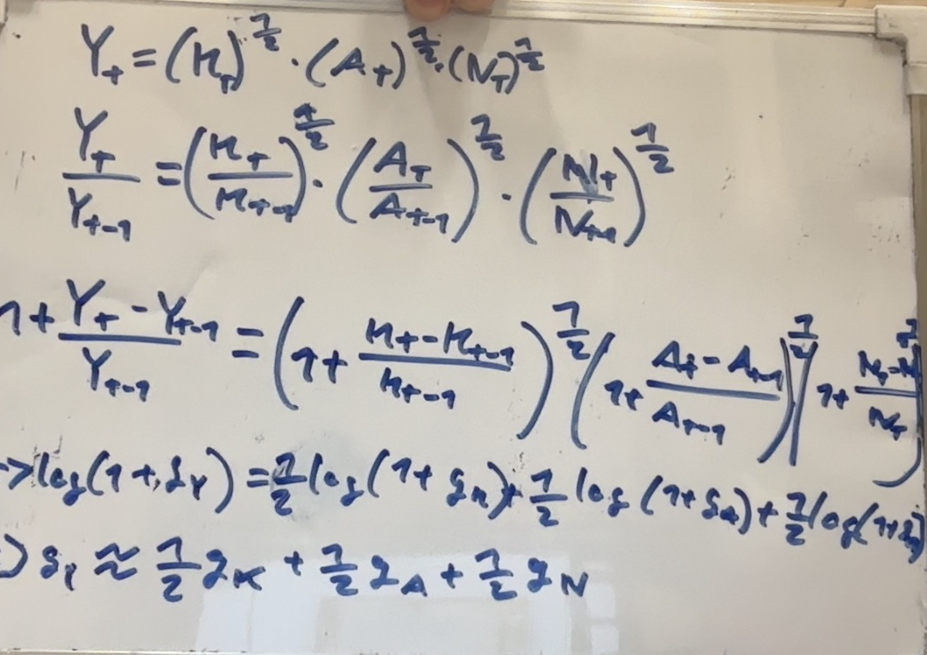
From the function we can simply put on a time index then do some manipulation and end up with a formula for growth in this specific economy
$$g_{Y}=\frac{1}{2}g_{K}+\frac{1}{2}g_{A}+\frac{1}{2}g_{N}⇔growth residual=\frac{1}{2}g_{A}=g_{Y}-\frac{1}{2}g_{K}-\frac{1}{2}g_{N}$$
$$residual=7-4-1=2\%$$
d) $g_{A}=2·residual=4\%$

e) the growth coming from kapital accumulation is quite high so would say that we are far from balanced growth
$$\frac{1}{2}·8\%=4\%$$
More than half of total growth is coming from capital accumulation
In balanced growth we sould expect allmost all growth to be coming from technology and population

